

**EMPLOYEE JOINING FORM**

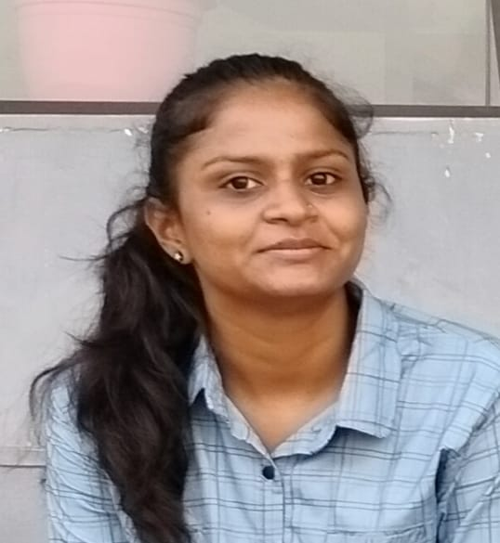**CONFIDENTIAL**

|  |  |  |  |
| --- | --- | --- | --- |
| Position | INTERN | Site Location | AHMEDABAD |
| Department | SOFTWARE | Designation | INTERN |
| Mobile. No | 6358737303 | DOJ | 26/12/2022 |

|  |  |  |  |  |  |
| --- | --- | --- | --- | --- | --- |
| **PERSONAL DATA** | | | | | |
| **Full Name (Block Letters)** | | | | | |
| First Name | VIDHI | Middle Name | TRUSHARBHAI | Surname | TRIVEDI |
| Date of Birth | 08/07/2002 | **Age** | 21 | **Sex** | FEMALE |
| Blood Group | B+ | **Marital Status** | UNMARRIED | **Wedding Anniversary Date** | — |
| License No. |  | License Expiry |  | PAN Number | BYNPT0979B |
| Nationality | INDIAN | Religion | HINDU | Aadhar Card Number | 628742967149 |
| Official Email Id | vidhitrivedi8722@gmail.com | | Personal Email ID | vidhitrivedi8722@gmail.com | |
| Bank Details: Account No | 36748342395 | | Bank Details: IFSC Code | SBIN0015235 | |

|  |  |  |  |  |  |  |  |
| --- | --- | --- | --- | --- | --- | --- | --- |
| Permanent Address | | | | Residential Address | | | |
| Floor/Apprt | “KAILASH” | | | Floor/Apprt | | B11,NEWYORK DARSHAN APPARTMENT | |
| Street | LAST STREET,GANATRA HALL MAIN ROAD,RAMNATH SOCIETY | | | Street | | NR. STERLING CITY GATE BRTS STOP,BOPAL-GHUMA ROAD | |
| City /State | JAM-KHAMBHALIA/GUJARAT | | | City /State | | AHMEDABAD/GUJARAT | |
| Phone No. | 6358737303 | | | Phone No. | | 6358737303 | |
| **FAMILY DETAILS** | | | | | | | |
| Name | | | Occupation | | Birth Date | | Mobile Number |
| Father | | TRUSHARBHAI B. TRIVEDI | LAWYER | | 6/11/19 | | 9898272166 |
| Husband/Wife | | — |  | |  | |  |
| Mother | | MANISHABEN T. TRIVEDI | SOCIAL WORKER | | 20/12/ | | 6358737302 |
| Brother/Sister1 | | VISHESH T. TRIVEDI | STUDENT | | 28/11/2004 | | 8849915413 |
| Brother/Sister2 | |  |  | |  | |  |
| Brother/Sister3 | |  |  | |  | |  |
| Name | | | Age | | Birth Date | | Boy/Girl |
| Child1 | |  |  | |  | |  |
| Child2 | |  |  | |  | |  |
| Child3 | |  |  | |  | |  |

|  |
| --- |
| APPENDIX OPERATION BEFORE 4 YRS |

|  |  |  |  |  |
| --- | --- | --- | --- | --- |
| **LANGUAGES KNOWN (Please Tick)** | | | | |
| Languages | Speak | Read | Write | Understand |
| English |  |  |  |  |
| Hindi |  |  |  |  |
| Gujarati |  |  |  |  |

|  |  |  |  |
| --- | --- | --- | --- |
| **WHOM TO CONTACT IN CASE OF EMERGENCY** | | | |
| Name | Address | Relation | Phone |
| TRUSHARBHAI TRIVEDI | RAMNATH SOCIETY,JAM-KHAMBHALIA,  361305 | FATHER | 9898272166 |
| MANISHABEN TRIVEDI | RAMNATH SOCIETY,JAM-KHAMBHALIA,  361305 | MOTHER | 6358737302 |
| TRUPTIBEN SHAH | NR. STERLING CITY GATE BRTS STOP,BOPAL-GHUMA ROAD,AHMEDABAD | PG OWNER | 9724773974 |
| **QUALIFICATION & CERTIFICATIONS** | | | |  |

|  |  |  |  |  |  |
| --- | --- | --- | --- | --- | --- |
| Qualification Name | Board/University | Name of the school/College and | Main Subjects | Passing Year | % Mark/Grade |
| 10th | GSEB | ST. KARVE SCHOOL | SCIENCE, MATHS,SOCIAL SCIENCE,HINDI,  GUJARATI | 2017 | 73 |
| 12th | GSEB | DREAM INTERNATIONAL SCHOOL | PHYSICS,CHEMISTRY,  MATHS,COMPUTER, | 2019 | 63 |
| Diploma | — | — | — | — | — |
| B.TECH | GANPAT UNIVERSITY | U.V.P.C.E | ALL COMPUTER SCIENCE CORE SUBJECTS | 2023 | 71.9 |
|  |  |  |  |  |  |
|  |  |  |  |  |  |

|  |  |
| --- | --- |
| **ANY AWARDS / SCHOLARSHIP:** | |
| 1. | 5TH RANK IN VEDIC MATHS COMPETITION,CHENNAI |

|  |  |  |  |  |  |  |  |
| --- | --- | --- | --- | --- | --- | --- | --- |
| **TRAINING COURSES ATTENDED**  **(Training Programs, Seminars, Conferences) (India & Abroad)** | | | | | | | |
| Name of The Program | | Institution  Conducting | | Duration | | Year | |
|  | |  | |  | |  | |
|  | |  | |  | |  | |
|  | |  | |  | |  | |
|  | |  | |  | |  | |
| **WORK EXPERIENCE (Most Recent Job First)** | | | | | | | |
| Name Of  Company | Designation | | Start Date | | End Date | | Gross Salary |
|  |  | |  | |  | |  |
|  |  | |  | |  | |  |
|  |  | |  | |  | |  |
|  |  | |  | |  | |  |
|  |  | |  | |  | |  |
|  |  | |  | |  | |  |
|  |  | |  | |  | |  |
|  |  | |  | |  | |  |

|  |  |  |  |  |
| --- | --- | --- | --- | --- |
| **PROFESSIONAL REFERENCES (Other Than Your Relatives)** | | | | |
| Name | Address | Occupation | Phone No | May We  Contact |
|  |  |  |  |  |
|  |  |  |  |  |

|  |  |
| --- | --- |
| **SELF EVALUATION** | |
| Strengths   * MY FRIENDLY NATURE * CONFIDENCE * COMMUNICATION SKILL * PASSIONATE * DON’T GIVE UP ATTITUDE | Short term Goal :   * ACHIEVING A GOOD PLACE FOR MY CAREER GROWTH. |
| Weakness   * TOO MUCH HELPFUL NATURE SOMETIME BACKFIRES. | Long-term Goal :   * HAVING A GOOD INDUSTRIAL EXPOSURE |

|  |  |
| --- | --- |
| **ENCLOSED DOCUMENTS** | |
| 1. | 10TH  MARKSHEET |
| 2. | 12TH MARKSHEET |
| 3. | 1-6 GRADUATE MARKSHEET |
| 4. | PAN CARD |
| 5. | AADHAR CARD |
| 6. | PASSBOOK FIRST PAGE |
| 7. | Covid-19 Vaccine Certificate |
| 8. |  |

I certify that the foregoing information is correct and complete to the best of my knowledge and belief & that nothing has been concealed. If at any point of time, I am found to have concealed any material information or given any false details against any of the above particulars, my appointment shall be liable to Summary Termination, without notice.

Date: 26/12/2022



_________________________

Signature of the Employee